Code review Assignment.
Ciaran Gray 22427722.

This following code is the code which I would like to be reviewed. It is c code which prompts the user to enter a month and a year and then prints out accurate monthly calanders for the desired months. Here is how it should look running:
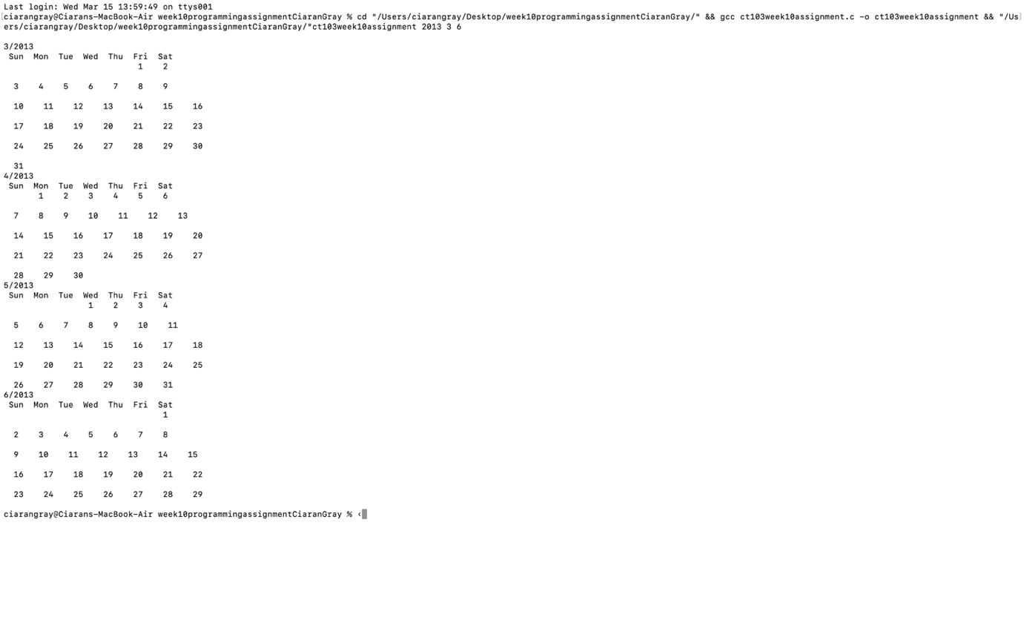
#include <stdio.h>
#include <stdlib.h>

int is_leap(int year);
int new_years_day(int year);
int no_of_days(int year, int month);
int first_day(int year, int month);
void print_month(int firstday, int numofdays);

int main(int argc, char *argv[]) {
int year = atoi(argv[1]);
int month = atoi(argv[2]);
int lastmonth = atoi(argv[3]);

is_leap(year); //calling all the functions
new_years_day(year);
no_of_days(year, month);
first_day(year, month);

for(int i = month; i <= lastmonth; i++) { // calling the function to print the calander
print_month(month, year);
month++;

if(month > 12) { //in case the calander needs to change into a new year
month = 1;
year++;
}
}
}

int is_leap(int year) {
if (year % 400 == 0) {
return 1;
}
else if (year % 100 == 0) {
return 0;
}
if (year % 4 == 0) {
return 1;
}
return 0;
}

int new_years_day(int year) { // this function gets the date of the first of any given year by looping through each year and adding 365 to the day variable and 1/0 depending if its a leap year until the desired year is reached
int day = 1;
for (int i = 1900; i < year; i++) {
day = (day + 365 + is_leap(i));
}
return (day % 7);
}

int no_of_days(int year, int month) { // this function gets the number of days in each month and will either add on 1 or 0 to febuary depending if its a leap year
if ((month == 1) || (month == 3) || (month == 5) || (month == 7) || (month == 8) || (month == 10) || (month == 12)) {
return 31;
}
else if((month != 2)) {
return 30;
}
return (28 + is_leap(year));
}

int first_day(int year, int month) {
int firstDay = new_years_day(year); // this function gets the date of the first of jan of that year, then calculates the first of the required month of that year by getting the number of days from jan 1st to the first of the month
for (int i = 1; i < month; i++) {
firstDay = firstDay + no_of_days(year, i);
}
return (firstDay % 7);
}

void print_month(int month, int year) {
printf("\n%d/%d", month, year);
printf("\n Sun Mon Tue Wed Thu Fri Sat\n");
int firstday = first_day(year, month);
int numofdays = no_of_days(year, month);

for(int i =0; i < firstday; i++) { // to start the printing of the dates on the first of the month
printf(" ");
}
int currday =1; // current day of week
int endofweek = firstday; // endofweek is a counter to match the currrent date with the correct day
for (currday = 1; currday <= numofdays; currday++) { // for loop that prints the dates with a if statement that moves the dates to a new line everytime it reaches sunday
printf(" %d ", currday);
endofweek++;
if(endofweek == 7) {
printf("\n\n");
endofweek = 0;
}
}
}

Creator: Oisin Mc Laughlin

Brief Summary: this is a c code that creates a battleship type game where the code generates random numbers and guesses a coordinate on a 6x6 grid until it guesses the location of a “ship”

/*
Name: Oisin Mc Laughlin
Student ID: 22441106
Date: 17/1/23
*/

#include <stdio.h>
#include <string.h>
#include <stdlib.h>
#include <time.h>

//Initialising global variables.
int shipX;
int shipY;
int gridsize = 6;

//Initialising functions.
void randomSearch(int gsize);
void gridSearch(int gsize, int ltries);

int main() {
//Randomising ships x and y between 0 and 5.
long lt = time(NULL);
srand(lt);
shipX = (rand() % 6);
shipY = (rand() % 6);

//Printing ships locations.
printf("\n");
printf("Ship X Location: %d\n", shipX);
printf("Ship Y Location: %d\n", shipY);
printf("(%d, %d)\n", shipX, shipY);

//Calling Random Search and Grid Search functions with their parameters.
printf("\n");
printf("Random Search\n");
randomSearch(gridsize);
printf("\n");
printf("Grid Search\n");
gridSearch(gridsize, 0);
printf("\n");
return 0;
}

void randomSearch(int gsize) {
//Initialising i as well as random x and y variables as -1.
int i = 0;
int randX = -1;
int randY = -1;

//While random x location or random y location (random number generated between 0 and 5), add 1 to i for attempts, repeat.
while ((!(randX == shipX)) || (!(randY == shipY))) {
i++;
randX = (rand() % (gsize-1));
randY = (rand() % (gsize-1));
}

//Once x and y are found, printing where it is as well as the amount of attempts it took.
printf("Location found from random: (%d, %d)\n", randX, randY);
printf("Found after %d random attempts\n", i+1);
}

void gridSearch(int gsize, int ltries) {
//Initialising variables, x as location tries modulus grid size and y as location tries divided by grid size.
int searchX = (ltries % gsize);
int searchY = (ltries / gsize);

//If searched x and searched y is the same as ship x and ship y, print location found and the amount of attempts.
if ((searchX == shipX) && (searchY == shipY)) {
printf("Location found from search: (%d, %d)\n", searchX, searchY);
printf("Found after %d search attempts\n", ltries);
}
//Otherwise call function again with same grid size and tried locations + 1.
else {
gridSearch(gridsize, (ltries+1));
}

/*for (int searchX = 0; searchX < gsize; searchX++) {
for (int searchY = 0; searchY < gsize; searchY++) {
if (searchX == shipX && searchY == shipY) {
printf("Found ship at location (%d, %d)\n", searchX, searchY);
printf("Found after %d search attempts\n", ltries);
return;
}
ltries++;
}
}
gridSearch(gsize, ltries);*/
}

Comments:
- This code is full of comments and easy to follow through the instructions provided
- It runs successfully and does exactly what its purpose is.
- I cant identify any potential errors you might have while running the code as it’s principle is relatively simple
- I believe that perhaps the game could be approached a different way by letting the user guess a random number themselves and try and guess where the “ship” is, this way there would be a better interaction between the user and the game.
- In my opinion it would help to add in an error message for any failures in generating the random numbers.
- The code utilizes four different libraries which is helpful.
- The data flow is understandable and I can clearly see where the ship’s location and the random guesses are being stored in variables.
- I think the code could be made slightly more entertaining if a feature was added where the code stopped running after a certain amount of random guesses.

Requested Change | Description
Added error message for potential error | You could add an if statement that checks that the random generated guesses are between 1 and 6 and prints out an error if its not true just to make it easier for the user to understand when the code isn’t working properly
Added feature for user guesses | Instead of comparing the randomly generated guesses to the ship’s coordinates, you could allow the user that enters a guess in the x and y coordinates and compare those guesses to the ship’s coordinates
Added feature for a maximum amount of guesses | A simple while loop could be added to the code that stops the code running when the tries variable reaches a desired number, such as 6.

